**KS4 Year 10 / 11 – AQA GCSE Design & Technology**

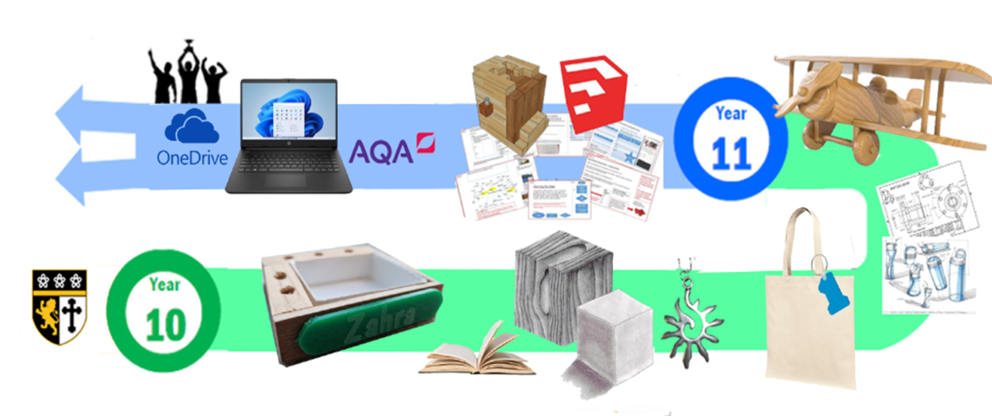

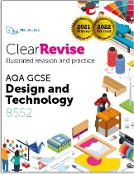

|  |
| --- |
| **Year 10** |
| ***Autumn Term***  **Timbers**  Learning the theory elements of natural woods, manufactured boards and processes, how to use and work with them.  Practical outcome: skills build using hand and machine tools to create a wooden plane.  Assessment: written exam to demonstrate knowledge and understanding. |
| **Drawing Skills and Google SketchUp**  Understanding how to draw out and communicate ideas, and how to present them with precision. The formal element of drawing, to an engineer’s standard is encompassed here.  ***Spring Term***  Practical outcome: isometric, orthographic and freehand drawings including how to render precisely. The use of Computer Aided Design (2D Design and Google SketchUp) leads to a skills build practical outcome of a desk tidy product which incorporates joining methods, use of the laser cutting and vacuum forming.  Assessment: presentation of the technical drawings and a mixed material desk tidy product is created focussing on progression of skill and accuracy. |
| **Core material areas**  Understanding materials and their working properties: textiles, polymers, metals, papers and boards and a range of focused practical tasks to embed knowledge and understanding. |
| **Wider theoretical knowledge**  A combination of strategies are used here along with the GCSE revision guide to aid learning and lessons.  Students learn about the following topics: new and emerging technologies, energy generation and storage, development in new materials, systems approach to designing, mechanical devices, forces and stresses, ecological and social footprint, scales of production and specialist techniques and processes. |
| ***Summer Term***  **Mock NEA**  Students will be given a condensed version of a GCSE contextual challenge brief and will produce accompanying designing work and a prototype of their chosen idea. |
| **AQA Non-Examined Assessment (NEA) worth 50% of the final grade.**  This is a coursework project done electronically on One Drive using PowerPoint. Students will produce a portfolio of evidence alongside a prototype, marked out of 100. This work will be marked internally by teachers and moderated externally by AQA. The NEA contextual challenges are released at the beginning of June; students will follow the iterative design process applying their knowledge. |
| **NEA Section A –** Identifying and investigating design possibilities (10 marks)  Students will identify a problem that needs to be solved highlighted by an intended client/user. They will research how this could potentially be designed and look at different sources of inspiration. |
| **NEA Section B** – Producing a design brief and specification (10 marks)  Students are to state how they intend to solve the problem and write out the requirements of their concept. |
| **Year 11** |
| ***Autumn Term***  **NEA Section C** – Design ideas, development, CAD/CAM and prototyping (25 marks)  **NEA Section D** – Realising design ideas (25 marks)  Drawings by hand, modelling on Google SketchUp and card/other materials prototyping is used to present ideas and test solutions. |
| ***Spring Term***  **NEA Section E** – Analysing and evaluating (20 marks)  Students conclude, test and evaluate their final outcome and present findings to their intended user summarising their work. |
| **Revision for Exam**  Students will cover a vast range of topic areas from AQA specification and use their revision guide alongside various revision strategies to help them prepare for their exam. Theory work from Year 10 will be revisited. |
| ***Summer Term***  **GCSE AQA Design & Technology Written Exam worth 50% of the final grade.**  **Section A** – *Core technical principles (20 marks)*- A mixture of multiple choice and short answer questions assessing a breadth of technical knowledge and understanding.  **Section B**– *Specialist technical principles (30 marks)*- Several short answer questions and one extended response to assess a more in depth knowledge of technical principles.  **Section C**– *Designing and making principles (50 marks)*- A mixture of short answer and extended response questions. |